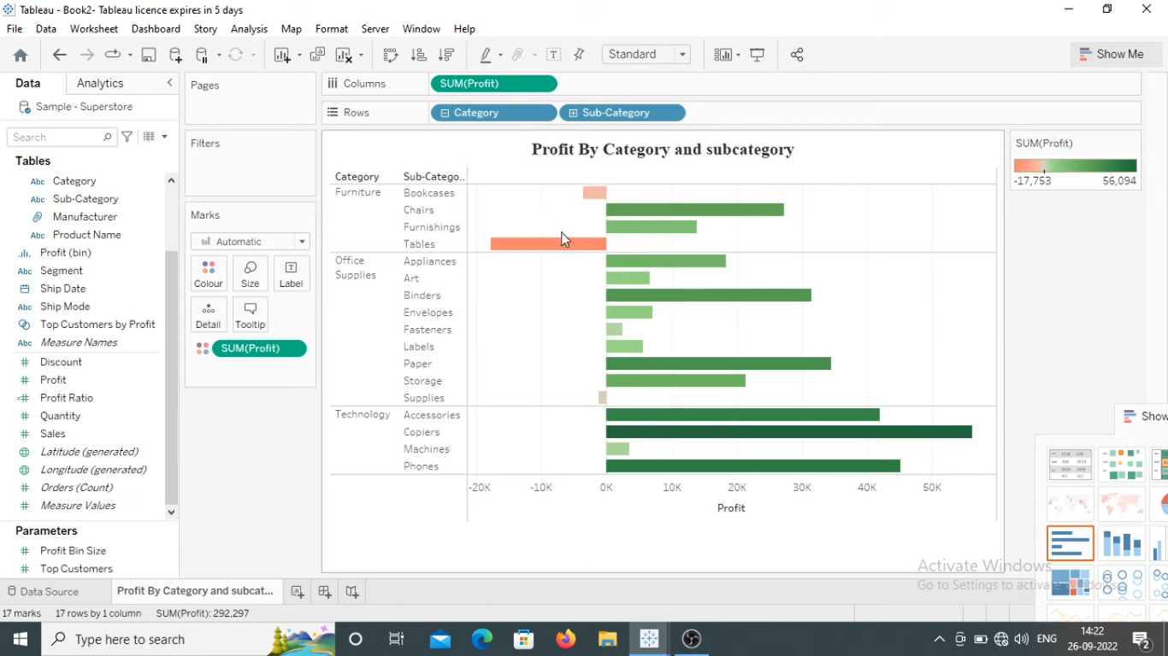

Step 1 :

Step2 :

Drag State on the heet directly and also drag profit on the sheet directly

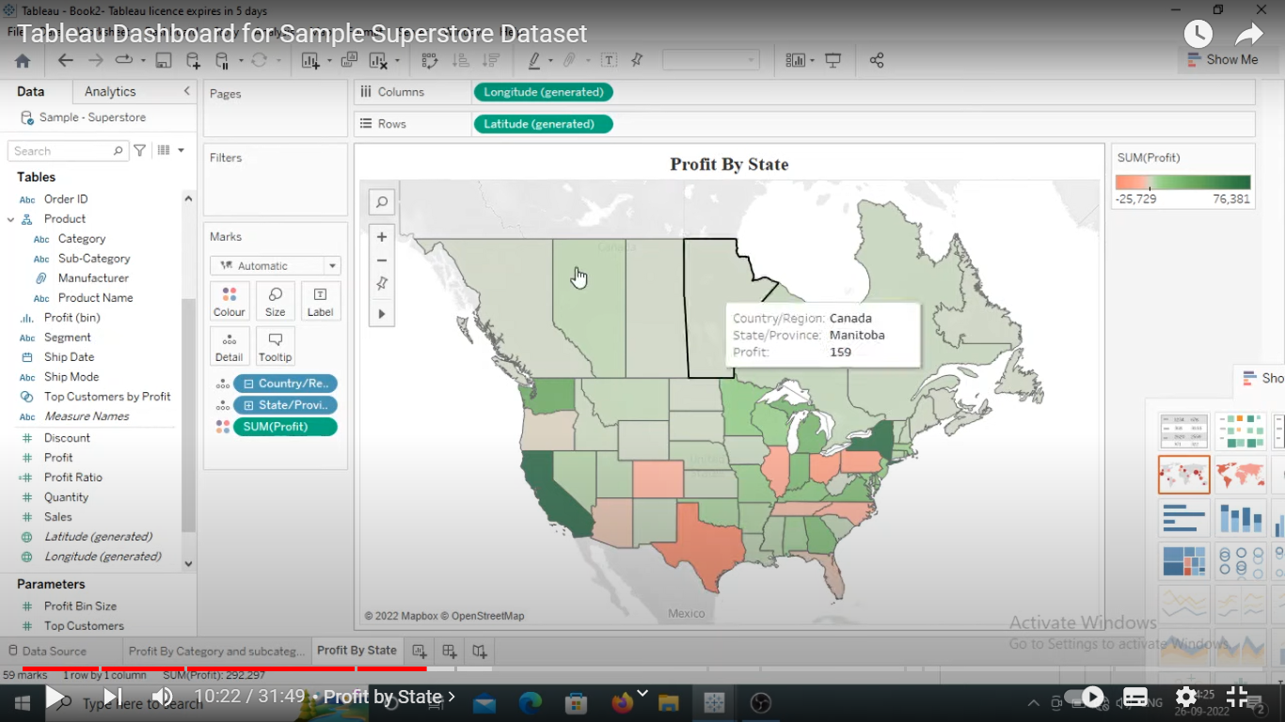

Step 3:

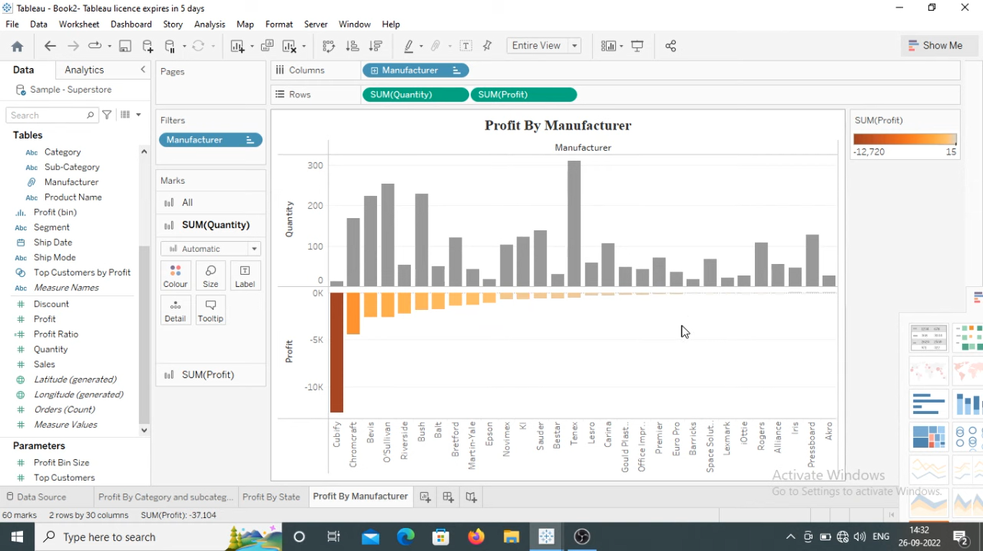

Manufacturer Filter – General -> use all

Top -> Bottom 30 Profit

Create a dashboard:

1. Click on use as filter to all sheet
2. 
3. 
4. For all the right side column select apply to Worksheet -> all using related data sources
5. For category and sub category select only relevant value option